

**DAS_________**

**TOPICAL QUESTIONS FOR P.7 TERM 1 2019**

**SCIENCE NO. 1**

School…………………………………………………………………………………………………………………

Name: ……………………………………………………………… Stream: …………………………………

**TOPIC: MUSCULAR – SKELETAL SYSTEM**

1. What is a skeleton?

………………………………………………………………………………………………………………………………

1. State anyone function of the human skeleton.

………………………………………………………………………………………………………………………………

1. Write down anyone type of skeleton.

………………………………………………………………………………………………………………………………

1. State the most essential mineral salts needed for proper growth and development of bones and teeth.

………………………………………………………………………………………………………………………………

1. Explain the importance of the cartilage structure found in the outer ear of most mammals?

……………………………………………………………………………………………………………………………..

1. Name anyone main part of the human body.

………………………………………………………………………………………………………………………………

1. Which delicate body organ is protected by the cranium?

……………………………………………………………………………………………………………………………..

1. Give one value of the skeletal system to the circulatory system.

……………………………………………………………………………………………………………………………..

1. How does ball and socket differ from hinge joint in terms of movement?

……………………………………………………………………………………………………………………….........................................................................................................................................

1. How are muscles connected to bones in the body?

…………………………………………………………………………………………………………………………….

1. State the value of the ligament at a joint?

…………………………………………………………………………………………………………………………….

1. Name any two types of joints in the human body.
2. …………………………………………………………………………………………………………………….
3. ……………………………………………………………………………………………………………………..
4. State the value of synovial fluid at a joint.

………………………………………………………………………………………………………………………….

1. Give anyone example of a voluntary muscle in the human body.

…………………………………………………………………………………………………………………………….

1. What are voluntary muscles?

……………………………………………………………………………………………………………………………………………………………………………………………………………………………………………………………..

1. State the value of good posture to an individual.

………………………………………………………………………………………………………………………………

1. Write down any two diseases which affect the skeletal system.
2. ………………………………………………………………………………………………………………………
3. ………………………………………………………………………………………………………………………
4. Name the deficiency disease which affects the skeletal system.

…………………………………………………………………………………………………………………………….

1. Write down any four disorders of the skeletal system
2. ……………………………………………………………………………………………………………………..
3. …………………………………………………………………………………………………………………….
4. ……………………………………………………………………………………………………………………..
5. ……………………………………………………………………………………………………………………..
6. Which part of the skeletal system protects;
7. The heart and the lungs

……………………………………………………………………………………………………………………….

1. The brain

………………………………………………………………………………………………………………………

1. The spinal cord

……………………………………………………………………………………………………………………..

1. The reproductive organs

……………………………………………………………………………………………………………………..

1. What is dislocation?

……………………………………………………………………………………………………………………………………………………………………………………………………………………………………………………………..

1. What is a fracture?

…………………………………………………………………………………………………………………………….

1. Name one activity that can maintain the healthy conditions of the skeletal system?

…………………………………………………………………………………………………………………………….

1. Name any two short bones from which red blood cells are made?
2. ……………………………………………………………………………………………………………………….
3. ……………………………………………………………………………………………………………………….
4. Identify one water borne disease of the skeletal system.

……………………………………………………………………………………………………………………………..

1. The diagram below shows the human arm, use it to answer the questions that follow

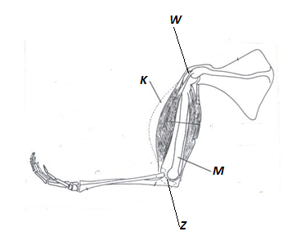

1. Name the parts marked K and M

K …………………………………………………… M: ……………………………………………………..

1. Name the kind of movement possible at W and Z

W: …………………………………………………………………………………………………………………….

Z: ……………………………………………………………………………………………………………………..



**DAS____________**

**TOPICAL QUESTIONS FOR P.7 TERM 1 2019**

**SCIENCE NO. 2**

School…………………………………………………………………………………………………………………

Name: ……………………………………………………………… Stream: …………………………………

**TOPIC: ELECTRICITY AND MAGNETISM**

1. What is matter?

………………………………………………………………………………………………………………………………………………………………………………………………………………………………………………………………

1. What is matter made up of?

…………………………………………………………………………………………………………………………..

1. How does mass differ from volume?

……………………………………………………………………………………………………………………………………………………………………………………………………………………………………………………………..

1. Give anyone advantage of using electricity for cooking.

……………………………………………………………………………………………………………………………………………………………………………………………………………………………………………………………..

1. What is the function of a fuse in an electric circuit?

……………………………………………………………………………………………………………………………..

1. How does a fuse work?

……………………………………………………………………………………………………………………………………………………………………………………………………………………………………………………………..

1. How can short circuits be prevented?

……………………………………………………………………………………………………………………………..

Below is an electric circuit diagram, use it to answer the questions that follow

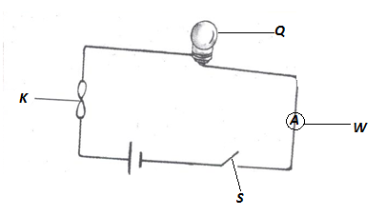

1. Name the parts marked S and W

S: ………………………………………………. W: ………………………………………………………

1. Give the function of part marked K in the circuit.

………………………………………………………………………………………………………………………………

1. Name any two energy changes that take place in part Q when S is closed?
2. ……………………………………………………………………………………………………………………….
3. ……………………………………………………………………………………………………………………….
4. How is part K similar to parts S in terms of function?

…………………………………………………………………………………………………………………………….

1. What type of energy is stored in part Q?

…………………………………………………………………………………………………………………………..

1. Name any two forms of energy produced at Q when the circuit has been completed?
2. ……………………………………………………………………………………………………………………
3. …………………………………………………………………………………………………………………….
4. Using arrows on the diagram, show the flow of current.
5. Name an example of static electricity in nature.

……………………………………………………………………………………………………………………………

1. What force enables the type named above to happen?

……………………………………………………………………………………………………………………………

1. Why is the bulb filament made coiled?

……………………………………………………………………………………………………………………………..

1. Name one device that converts electrical energy into mechanical energy?

…………………………………………………………………………………………………………………………….

1. How does electricity generated at Jinja get to a consumer in Kasese town?

………………………………………………………………………………………………………………………….

1. Why is it that most conducting wires are made of copper and aluminum not silver yet it is the best conductor?

……………………………………………………………………………………………………………………………………………………………………………………………………………………………………………………………..

1. Why should electricity wires be properly insulated?

……………………………………………………………………………………………………………………………..

1. Define the term magnetism?

……………………………………………………………………………………………………………………………..

1. Give any two properties of a magnet?
2. ………………………………………………………………………………………………………………………
3. ………………………………………………………………………………………………………………………
4. How can electromagnets be made stronger?

…………………………………………………………………………………………………………………………….

1. In what way is a magnet useful to a doctor in a hospital?

…………………………………………………………………………………………………………………………………………………………………………………………………………………………………………………………….

1. State any three ways of demagnetizing a magnet?
2. ……………………………………………………………………………………………………………………..
3. …………………………………………………………………………………………………………………….
4. ……………………………………………………………………………………………………………………..



**DAS_____________**

**TOPICAL QUESTIONS FOR P.7 TERM 1 2019**

**SCIENCE NO. 3**

School…………………………………………………………………………………………………………………

Name: ……………………………………………………………… Stream: …………………………………

**TOPIC: ENERGY RESOURCES**

1. What is a resource?

………………………………………………………………………………………………………………………………………………………………………………………………………………………………………………………………

1. Define the following terms;
2. Energy

………………………………………………………………………………………………………………………………………………………………………………………………………………………………………………

1. Energy resource

………………………………………………………………………………………………………………………………………………………………………………………………………………………………………………

1. Give any one reason why plants are regarded as energy resources?

………………………………………………………………………………………………………………………………………………………………………………………………………………………………………………………………

1. Identify two ways how man uses energy from the sun?
2. ………………………………………………………………………………………………………………………
3. ……………………………………………………………………………………………………………………..
4. Give any three forms of wood fuel used in production of heat and light.
5. ……………………………………………………………………………………………………………………..
6. ……………………………………………………………………………………………………………………..
7. ……………………………………………………………………………………………………………………..
8. Write any three energy resources obtained from underground.
9. …………………………………………………………………………………………………………………….
10. …………………………………………………………………………………………………………………..
11. …………………………………………………………………………………………………………………….
12. State the role of bacteria in a biogas production.

……………………………………………………………………………………………………………………………

1. How do energy saving stoves help to conserve the environment?

……………………………………………………………………………………………………………………………

1. List down any four materials that can be used to generate biogas?
2. …………………………………………………………………………………………………………………….
3. ……………………………………………………………………………………………………………………
4. ……………………………………………………………………………………………………………………
5. …………………………………………………………………………………………………………………..
6. List down any three fossil fuels obtained from underground?
7. ………………………………………………………………………………………………………………………
8. ………………………………………………………………………………………………………………………
9. ………………………………………………………………………………………………………………………
10. How can deforestation affect production of hydroelectricity at the Owen falls dam?

……………………………………………………………………………………………………………………………………………………………………………………………………………………………………………………………..

1. State three ways how wind can be an energy resource?
2. ………………………………………………………………………………………………………………………
3. ……………………………………………………………………………………………………………………….
4. ……………………………………………………………………………………………………………………….
5. Give the importance of solid residue after biogas production to a crop farmer?

………………………………………………………………………………………………………………………………

1. Give one way of maintaining soil fertility.

……………………………………………………………………………………………………………………………..

1. How is carbondioxide useful to man?

………………………………………………………………………………………………………………………………

1. Match items in list A with those in list B

Thermal electricity uranium

Nuclear electricity fossil fuels

Hydroelectricity water

Static electricity friction

Hot springs

1. ……………………………………………………………………………………………………………………….
2. ……………………………………………………………………………………………………………………….
3. ……………………………………………………………………………………………………………………….
4. ……………………………………………………………………………………………………………………….
5. Identify any four ways in which one can conserve resources from animals and plants
6. ………………………………………………………………………………………………………………………
7. ………………………………………………………………………………………………………………………
8. ……………………………………………………………………………………………………………………..
9. …………………………………………………………………………………………………………………….



**DAS_______**

**TOPICAL QUESTIONS FOR P.7 TERM 2 2019**

**SCIENCE NO. 4**

School……………………………………………………………………………………………………………

Name: ……………………………………………………………… Stream: ……………………………

**TOPIC: MACHINES**

1. What is a machine?

………………………………………………………………………………………………………………………………………………………………………………………………………………………………………………………………

1. How do simple machine simplify work?

……………………………………………………………………………………………………………………………..

1. What is friction?

………………………………………………………………………………………………………………………………………………………………………………………………………………………………………………………………

1. Name any three uses of friction?
2. ……………………………………………………………………………………………………………………….
3. ……………………………………………………………………………………………………………………….
4. ………………………………………………………………………………………………………………………
5. Identify one way in which friction is of a disadvantage.

………………………………………………………………………………………………………………………………

1. Give two ways of increasing friction?
2. ……………………………………………………………………………………………………………………….
3. ………………………………………………………………………………………………………………………
4. In which two ways is friction a nuisance force?
5. ……………………………………………………………………………………………………………………….
6. …………………………………………………………………………………………………………………
7. Identify any two ways of reducing friction.
8. ……………………………………………………………………………………………………………………..
9. ………………………………………………………………………………………………………………………
10. Why are objects like aeroplanes and boats streamlined?

…………………………………………………………………………………………………………………………….

The diagram below shows a pair of scissors

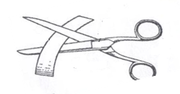

1. With the help of arrows, show the position of the effort, the fulcrum and the load.
2. To what class of levers do scissors belong?

………………………………………………………………………………………………………………………….

1. To what group of simple machines does an axe belong?

………………………………………………………………………………………………………………………….

1. State the law of moments.

………………………………………………………………………………………………………………………………………………………………………………………………………………………………………………………………

1. Eric pushed a wheel barrow using a force of 25Newtons for a distance of 17metres.Calculate the work done by Eric.

Study the diagram below and answer the questions that follow

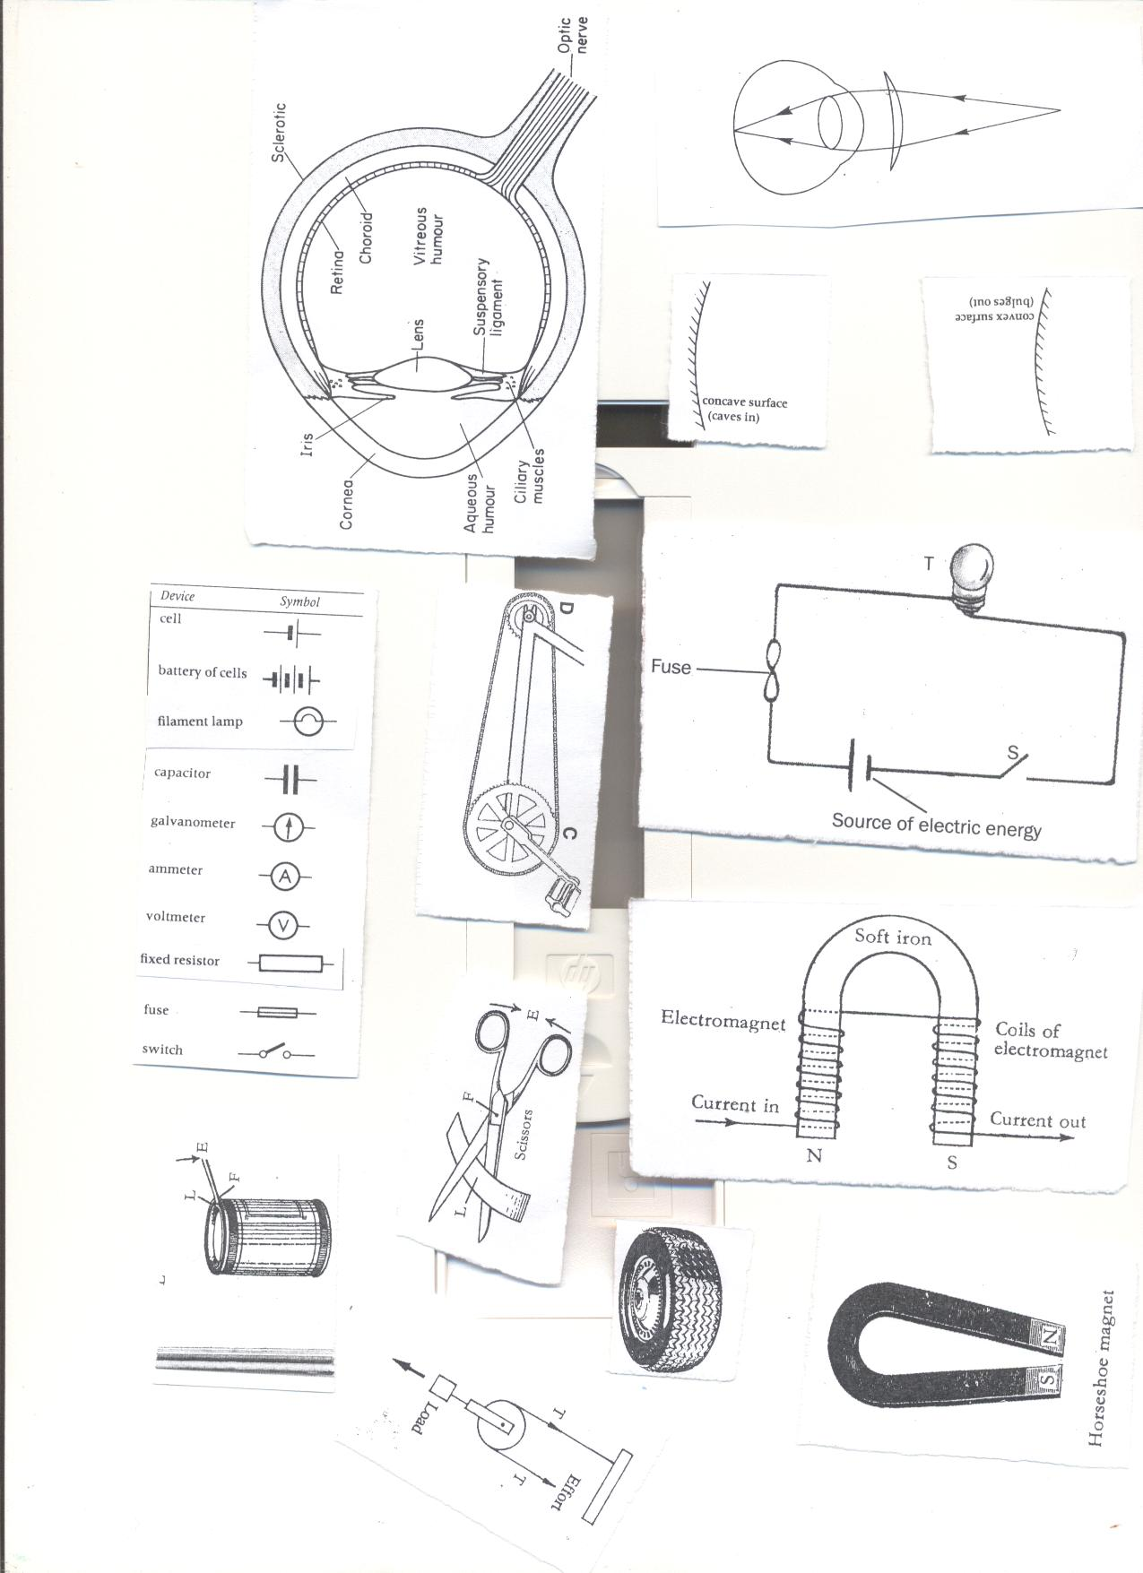 **Y X**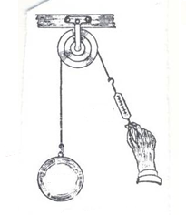

1. Name pulleys X and Y

X: ………………………………………………………………………………………………………………………..

Y: ………………………………………………………………………………………………………………………..

1. Which of the pulleys above needs less effort to raise a load of 60Newtons

……………………………………………………………………………………………………………………………

1. Why should ball bearing be put in parts of a bicycle?

………………………………………………………………………………………………………………………………………………………………………………………………………………………………………………………………

1. What is the function of an axe as a garden tool?

…………………………………………………………………………………………………………………………….

1. What would happen to a tool like an axe if left in moist area?

………………………………………………………………………………………………………………………………

**The diagram below shows a simple machine used to lift a load of 100kf with an effort of 50kgf**

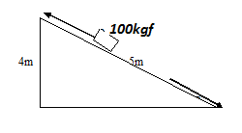

1. Name the simple machine shown above.

………………………………………………………………………………………………………………………………

1. What distance does
2. Load move

……………………………………………………………………………………………………………………..

1. Effort move

……………………………………………………………………………………………………………………….

1. What can you do to use less than 50kgf to pull the same load?

………………………………………………………………………………………………………………………………

1. Why are roads constructed with rough surfaces?

…………………………………………………………………………………………………………………………….

1. Give any one use of a pulley at your school.

…………………………………………………………………………………………………………………………….



**DAS__________**

**TOPICAL QUESTIONS FOR P.7 TERM 2 2019**

**SCIENCE NO. 5**

School…………………………………………………………………………………………………………………

Name: ……………………………………………………………… Stream: …………………………………

**TOPIC: EXCRETORY SYSTEM**

1. Define the term excretion

……………………………………………………………………………………………………………………………………………………………………………………………………………………………………………………………..

1. State the main function of the kidney in the body.

……………………………………………………………………………………………………………………………………………………………………………………………………………………………………………………………..

1. Where does filtration of blood to remove waste products take place in the kidney?

……………………………………………………………………………………………………………………………………………………………………………………………………………………………………………………………..

1. List down any three components of urine.
2. ……………………………………………………………………………………………………………………….
3. ……………………………………………………………………………………………………………………….
4. ………………………………………………………………………………………………………………………
5. How is the medulla an important part of the kidney?

……………………………………………………………………………………………………………………………………………………………………………………………………………………………………………………………..

1. State the role of the urinary bladder during excretion.

…………………………………………………………………………………………………………………………………………………………………………………………………………………………………………………………….

1. Name the water borne disease which attacks the urinary bladder.

…………………………………………………………………………………………………………………………….

1. Give anyone function of the human skin?

………………………………………………………………………………………………………………………………

1. Why do soles of the feet develop thick surfaces after doing heavy manual work?

……………………………………………………………………………………………………………………………..

1. State the two main layers of the human skin.
2. ………………………………………………………………………………………………………………………
3. ………………………………………………………………………………………………………………………
4. What pigment determines the skin colour?

……………………………………………………………………………………………………………………………..

1. How is the kidney similar to the skin in terms of function?

………………………………………………………………………………………………………………………………

1. Give any two components of the sweat.
2. ………………………………………………………………………………………………………………………
3. ……………………………………………………………………………………………………………………….
4. Write down any three diseases which attack the skin.
5. ………………………………………………………………………………………………………………………
6. ………………………………………………………………………………………………………………………
7. ……………………………………………………………………………………………………………………..
8. State the blood vessels which transports digested food materials from the ileum to the liver?

………………………………………………………………………………………………………………………….

1. State the main function of the liver in the body.

……………………………………………………………………………………………………………………………

1. Why are the lungs considered to be both excretory and respiratory organs?

…………………………………………………………………………………………………………………………..

1. State the function of the celia found in the nostrils of humans.

………………………………………………………………………………………………………………………….

1. Give the value of the epiglottis during digestion.

…………………………………………………………………………………………………………………………….

1. Why are we advised not to breathe through the mouth?

…………………………………………………………………………………………………………………………….

1. State the reason why the trachea is made of rings of cartilage.

……………………………………………………………………………………………………………………………

1. By what process does gaseous exchange take place in the lungs?

…………………………………………………………………………………………………………………………..

1. What important process takes place in the lungs?

……………………………………………………………………………………………………………………………

1. How are the air sacs adopted to their function?

………………………………………………………………………………………………………………………………

1. What happens to the diaphragm when we breathe in?

…………………………………………………………………………………………………………………………….

1. Name any two non-infectious diseases of the lungs?
2. ………………………………………………………………………………………………………………………
3. ……………………………………………………………………………………………………………………..
4. Identify any two ways of maintaining the health of the excretory system.
5. …………………………………………………………………………………………………………………….
6. ……………………………………………………………………………………………………………………..



**DAS__________**

**TOPICAL QUESTIONS FOR P.7 TERM 2 2019**

**SCIENCE NO. 6**

School…………………………………………………………………………………………………………………

Name: ……………………………………………………………… Stream: …………………………………

**TOPIC: LIGHT**

1. Name one natural source of light.

…………………………………………………………………………………………………………………………….

1. Give one difference between luminous and non-luminous object.

…………………………………………………………………………………………………………………………….

1. Identify the materials which;
2. Do not allow any light reaching them to pass through them

……………………………………………………………………………………………………………………….

1. Allows some light to pass through them

……………………………………………………………………………………………………………………..

1. Briefly explain how a solar eclipse is formed.

……………………………………………………………………………………………………………………………..

1. How is a shadow formed?

………………………………………………………………………………………………………………………………

1. State the difference between reflection and refraction?

………………………………………………………………………………………………………………………………

1. In the space provided below draw to show the difference between a converging and diverging beam of light?
2. What is the function of the sun in rainfall formation?

…………………………………………………………………………………………………………………………….

1. Complete the diagram below correctly

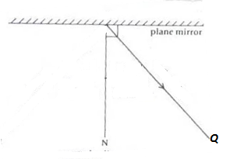

1. Name the ray marked **Q**

…………………………………………………………………………………………………………………………..

1. State anyone law of reflection?

…………………………………………………………………………………………………………………………….

1. How do images formed in pin hole camera differ from those in a plane mirror?

…………………………………………………………………………………………………………………………….

1. Describe an experiment to show that light travels in a straight line.

…………………………………………………………………………………………………………………………….

1. Why aren’t able to be around corners?

……………………………………………………………………………………………………………………………..

1. During a thunder storm, why is light seen before sound is heard?

……………………………………………………………………………………………………………………………..

The diagram shows two different lenses, use them to answer the questions that follow

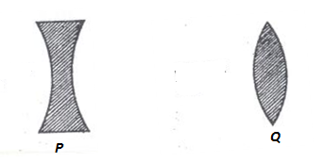

1. Name the lenses marked P and Q

**P** …………………………………………… **Q** ………………………………………………………..

1. What type of beam does lens **Q** produce when a parallel beam passes through it?

………………………………………………………………………………………………………………………………

1. The eye defect corrected by the lens marked by **P** and **Q**

**P** …………………………………………….. **Q** ………………………………………………………………

1. Name anyone eye disease caused by bacteria ………………………………………………………………………………………………………………………………
2. What causes refraction of light? ………………………………………………………………………………………………………………………………
3. What is dispersion of light? ………………………………………………………………………………………………………………………………
4. Why does a green mug appear green? ………………………………………………………………………………………………………………………………



**DAS___________**

**TOPICAL QUESTIONS FOR P.7 TERM 3 2019**

**SCIENCE NO. 7**

School…………………………………………………………………………………………………………………

Name: ……………………………………………………………… Stream: …………………………………

**POPULATION AND HEALTH**

1. Define the term human population? ………………………………………………………………………………………………………………………………
2. Write down any four health concerns common in your area? ………………………………………………………………………………………………………………………………
3. Identify any three human activities that can lead to poor sanitation. (i)……………………………………………………………………………………………………………………………

(ii) …………………………………………………………………………………………………………………………

(iii) …………………………………………………………………………………………………………………………

1. Give any two causes of sickness in a home.

(i) ………………………………………………………………………………………………………………………….

(ii) …………………………………………………………………………………………………………………………

1. Write two activities which can improve sanitation at home?

(i)……………………………………………………………………………………………………………………………

(ii)…………………………………………………………………………………………………………………………..

1. State three common anti-social behaviours in a school?

(i) …………………………………………………………………………………………………………………………

(ii) ………………………………………………………………………………………………………………………….

(iii) …………………………………………………………………………………………………………………………

1. Give any two natural changes which can result into insufficient food supply in a community?

(i) ………………………………………………………………………………………………………………………….

(ii) ………………………………………………………………………………………………………………………….

1. Identify any two ways how the government of Uganda has tried to improve on provision of clean water supply in your community?

(i) ………………………………………………………………………………………………………………………….

(ii) ………………………………………………………………………………………………….........................

1. What health problems can result from poor water supply in your area? ………………………………………………………………………………………………………………………………………………………………………………………………………………………………………………………………………………………………………………………………………………………………………………………………
2. Outline two ways how we can promote health in a community?

(i) …………………………………………………………………………………………………………………………

(ii) ………………………………………………………………………………………………………………………….

1. Give any two values of budgeting in a family? (i)……………………………………………………………………………………………………………………………

(ii) ………………………………………………………………………………………………………………………….

1. State any two values of healthsurveys on area (i)……………………………………………………………………………………………………………………………(ii)…………………………………………………………………………………………………………………………
2. Define the term demography as used in health education. ………………………………………………………………………………………………………………………………………………………………………………………………………………………………………………………………
3. Identify anyone health danger of staying in overcrowded areas? ………………………………………………………………………………………………………………………………
4. Give any two reasons why immunization of children is important? (i)……………………………………………………………………………………………………………………………(ii)…………………………………………………………………………………………………………………………..
5. State the importance of a child health card to;
6. Parent ……………………………………………………………………………………………………………………………………………………………………………………………………………………………………………….
7. Doctor ……………………………………………………………………………………………………………………………………………………………………………………………………………………………………………….
8. School health committee ……………………………………………………………………………………………………………………………………………………………………………………………………………………………………………….
9. Why should an expectant mother be immunized with tetanus toxoid? ………………………………………………………………………………………………………………………………………………………………………………………………………………………………………………………………
10. How is a health centre important to people in the community? ………………………………………………………………………………………………………………………………………………………………………………………………………………………………………………………………



**DAS___________**

**TOPICAL QUESTIONS FOR P.7 TERM 3 2019**

**SCIENCE NO. 8**

School…………………………………………………………………………………………………………………

Name: ……………………………………………………………… Stream: …………………………………

**TOPIC: INTERDEPENDENCE OF LIVING THINGS**

1. Define the term environment? ………………………………………………………………………………………………………………………………………………………………………………………………………………………………………………………………
2. Give anyone living component of the environment? ………………………………………………………………………………………………………………………………
3. Define the term interdependence? ………………………………………………………………………………………………………………………………………………………………………………………………………………………………………………………………
4. What is a resource? ………………………………………………………………………………………………………………………………………………………………………………………………………………………………………………………………
5. Identify any three resources from the environment. (i)……………………………………………………………………………………………………………………………(ii)…………………………………………………………………………………………………………………………..

(iii)………………………………………………………………………………………………………………………….

1. Give any two ways in which living things depend on nonliving things?
2. (i)……………………………………………………………………………………………………………………………………………………………………………………………………………………………………………………………(ii)…………………………………………………………………………………………………………………………………………………………………………………………………………………………………………………………
3. Identify two ways how animals depend on plants? (i)……………………………………………………………………………………………………………………………………………………………………………………………………………………………………………………………

(ii)…………………………………………………………………………………………………………………………………………………………………………………………………………………………………………………………

1. Give three ways in which plants benefit from animals? (i)……………………………………………………………………………………………………………………………………………………………………………………………………………………………………………………………(ii)…………………………………………………………………………………………………………………………………………………………………………………………………………………………………………………………(iii)…………………………………………………………………………………………………………………………………………………………………………………………………………………………………………………………
2. How do animals depend on each other? ………………………………………………………………………………………………………………………………………………………………………………………………………………………………………………………………
3. How do plants depend on plants? ………………………………………………………………………………………………………………………………………………………………………………………………………………………………………………………………
4. Study the organisms below and answer the questions that follow

Plant insects lizards hawks bacteria sun

1. What is the main role of the sun in the food chain? ………………………………………………………………………………………………………………………………
2. State one reason why plants are considered as producers? ………………………………………………………………………………………………………………………………………………………………………………………………………………………………………………………………
3. What scientific term best describes lizards in the food chain above ………………………………………………………………………………………………………………………………
4. What is agro- forestry? ………………………………………………………………………………………………………………………………
5. State anyone reason why people plant trees in their compounds? ………………………………………………………………………………………………………………………………………………………………………………………………………………………………………………………………
6. State the importance of agro – forestry to the farmer? ………………………………………………………………………………………………………………………………………………………………………………………………………………………………………………………………
7. Give any two qualities of good seeds or cuttings to be planted? (i)……………………………………………………………………………………………………………………………(ii)…………………………………………………………………………………………………………………………..
8. How does mulching improve soil fertility? ………………………………………………………………………………………………………………………………………………………………………………………………………………………………………………………………
9. How are sweet potatoes propagated? ………………………………………………………………………………………………………………………………
10. Give any two ways farmers can care for their trees in the garden? (i)……………………………………………………………………………………………………………………………(ii)…………………………………………………………………………………………………………………………..
11. Why do some trees need pollarching? ………………………………………………………………………………………………………………………………………………………………………………………………………………………………………………………………
12. Identify any three methods of harvesting wood (i)……………………………………………………………………………………………………………………………(ii)…………………………………………………………………………………………………………………………

(iii)…………………………………………………………………………………………………………………………

1. Give two methods of planting crops? (i)……………………………………………………………………………………………………………………………(ii)…………………………………………………………………………………………………………………………..
2. How do trees planted in a school garden prevent soil erosion? ………………………………………………………………………………………………………………………………………………………………………………………………………………………………………………………………
3. Write down any three common trees planted for provision of hard wood?

(i) ………………………………………………………………………………………………………………………….

(ii) ………………………………………………………………………………………………………………………….

(iii) …………………………………………………………………………………………………………………………

1. State the value of a nursery bed on a school farm? ………………………………………………………………………………………………………………………………
2. List down any two effects of crop pests to our produce? (i)……………………………………………………………………………………………………………………………

(ii) ………………………………………………………………………………………………………………………….

1. Match items in list **A** with those in list **B**

**A B**

Cassava American boll worm

Banana mosaic

Ground nuts panama

Maize rosette disease

Streak disease